What we need to do in relational database System

Step-1: Installation

1. **Database Engine selection** : Mysql
2. **Purpose of use**: Production/Non Production
3. **Database Specification**:
4. Database Engine Version
5. Number of CPU, RAM will use
6. Storage Type: general purpose
7. Storage Size: 5(gb)
8. Instance Name, Username, Password
9. Advance Configuration (Network and Sequrity)
10. VCP: Default VCP
11. VCP Security Group: Default VCP
12. Database Name: write your database name here

**Step-1: Go to “AWS management console”**

<https://console.aws.amazon.com/console/home?region=us-east-1>

and click “Database🡪RDS”

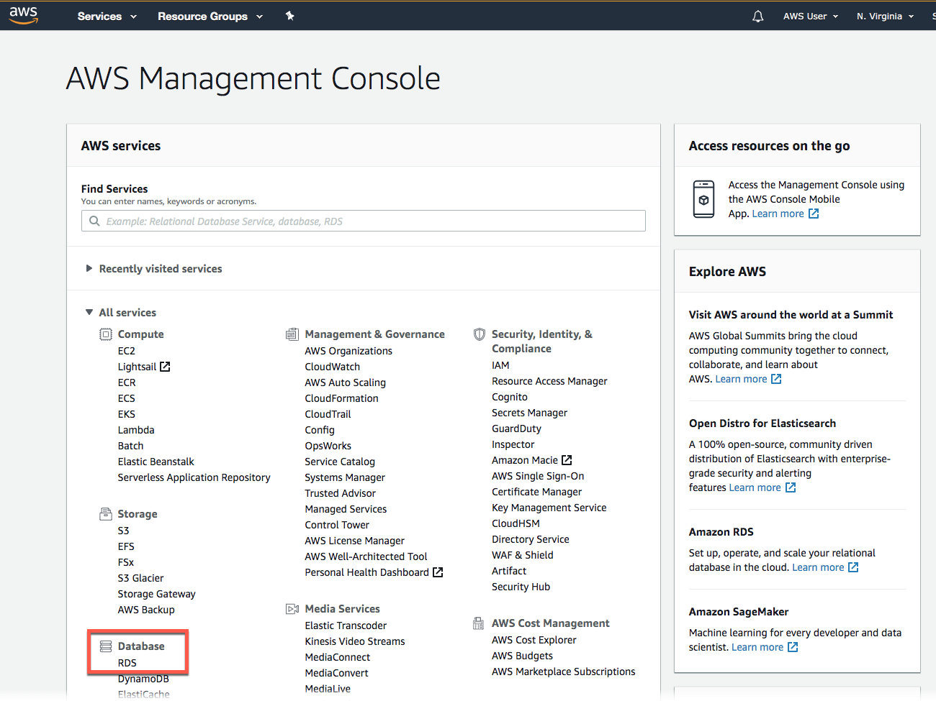

Step-2: **Create a MySQL DB Instance**

We will use Amazon RDS to create a MySQL DB Instance.

With

1. db.t2.micro DB instance class, 20 GB of storage
2. automated backups
3. all of this is free tier eligible (should be select)

**Select the *Region:***

In the top right corner of the Amazon RDS console, select the *Region* in which you want to create the DB instance.

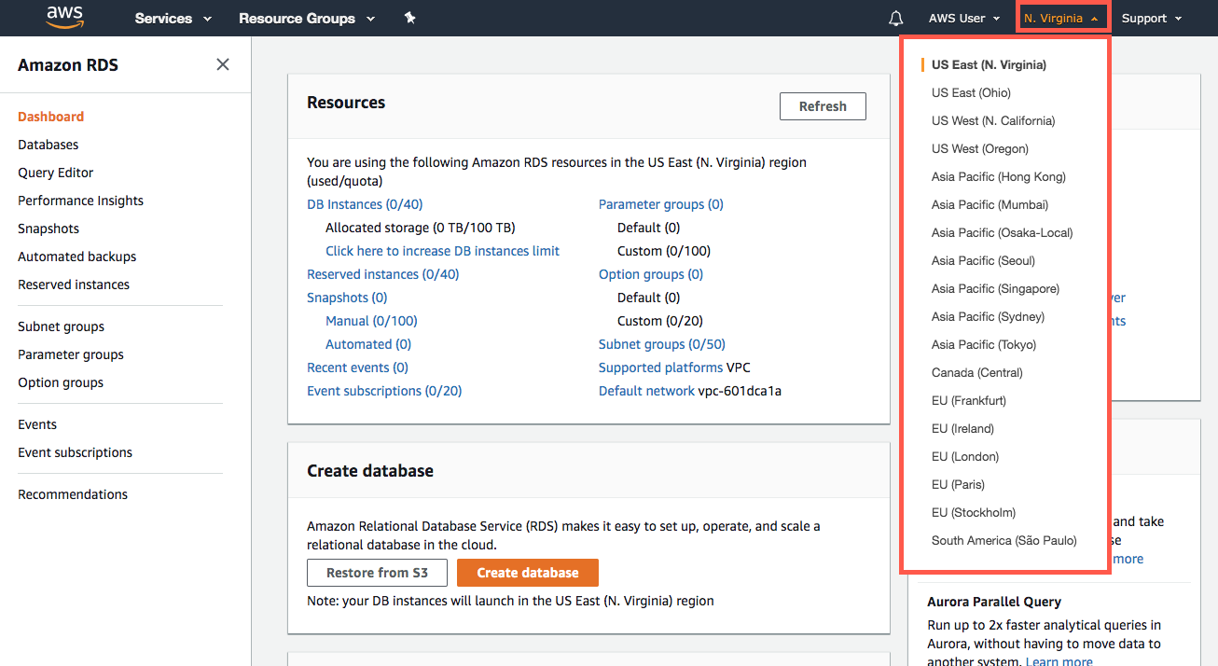

**Create database**

In Create database section, click on  **“Create database**” button



**Select your engine**

1. Database creation mode : Standard Create
2. Engine option: MySQL
3. Templates: Free Tier

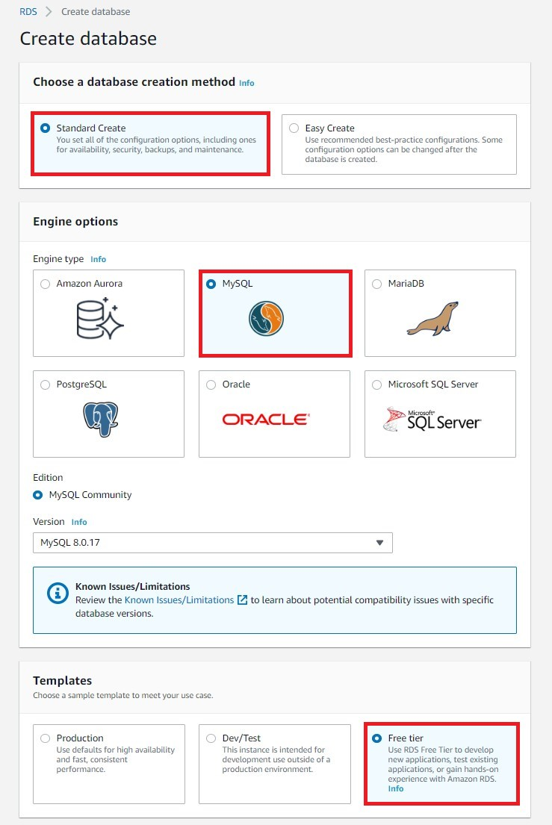

**Configure your DB instance**

**Settings**:

* **DB instance identifier**: Type a name for the DB instance that is unique for your account in the Region that you selected. For this tutorial, we will name it rds-mysql-10minTutorial.
* **Master username**: Type a username that you will use to log in to your DB instance. We will use masterUsername in this example.
* **Master password**: Type a password that contains from 8 to 41 printable ASCII characters (excluding /,", and @) for your master user password.
* **Confirm password**: Retype your password

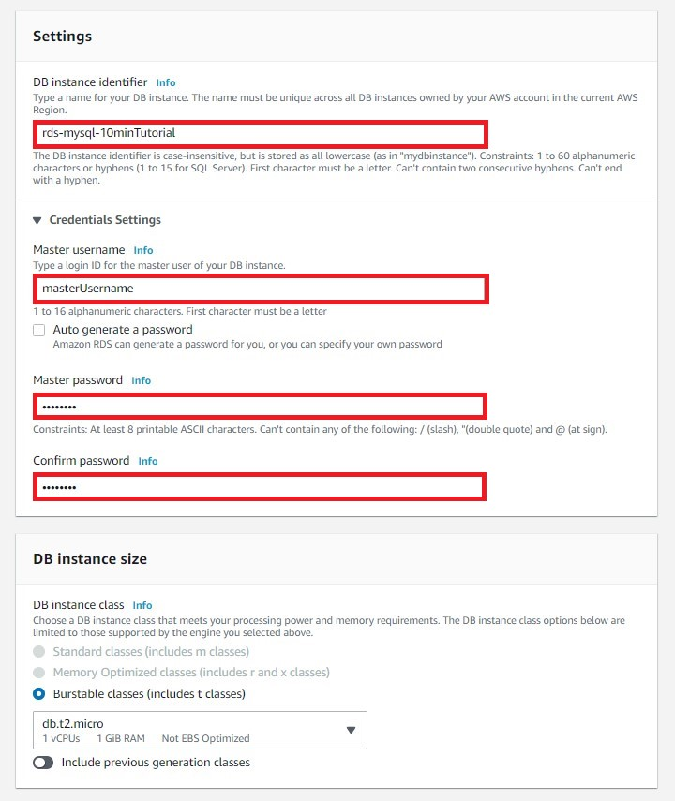

**Instance specifications:**

* **DB instance class**: Select *db.t2.micro --- 1vCPU, 1 GIB RAM*
* **Storage type**: Select *General Purpose (SSD)*.
* **Allocated storage**: Select the default of 20 (to allocate 20 GB of storage for your database. You can scale up to a maximum of 64 TB with Amazon RDS for MySQL).
* **Enable storage autoscaling**: If your workload is cyclical or unpredictable, you would enable storage autoscaling to enable RDS to automatically scale up your storage when needed. This option does not apply to this tutorial.
* **Multi-AZ deployment**: Note that you will have to pay for Multi-AZ deployment. Using a Multi-AZ deployment will automatically provision and maintain a synchronous standby replica in a different Availability Zone. For more information, see [High Availability Deployment](https://docs.aws.amazon.com/AmazonRDS/latest/UserGuide/Concepts.MultiAZ.html).

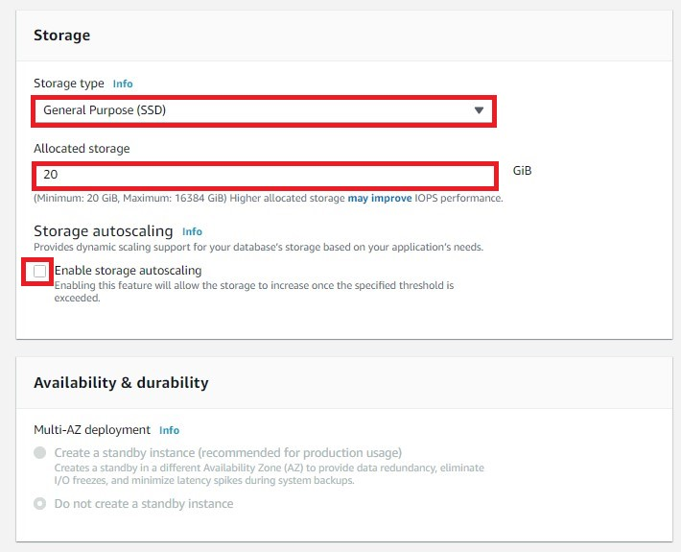

**Connectivity section**

**Connectivity**

* **Virtual Private Cloud (VPC)**: Select *Default VPC*.

**Additional connectivity configurations**

* **Subnet group**: Choose the *default* subnet group. For more information about subnet groups, see [Working with DB Subnet Groups](http://docs.aws.amazon.com/AmazonRDS/latest/UserGuide/USER_VPC.WorkingWithRDSInstanceinaVPC.html#USER_VPC.Subnets).
* **Public accessibility**: Choose *Yes*. This will allocate an IP address for your database instance so that you can directly connect to the database from your own device.
* **VPC security groups**: Select Create new VPC security group. This will create a security group that will allow connection from the IP address of the device that you are currently using to the database created.
* **Availability zone**: Choose *No preference*. See [Regions and Availability Zones](https://docs.aws.amazon.com/AmazonRDS/latest/UserGuide/Concepts.RegionsAndAvailabilityZones.html) for more details.
* **Port**: Leave the default value of 3306.

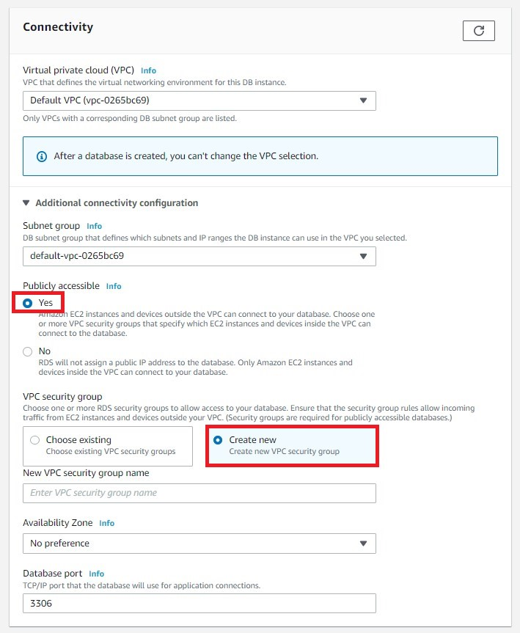

In the **Additional configurations** section:

**Database options**

* **Database name**: Type a database name that is 1 to 64 alpha-numeric characters. If you do not provide a name, Amazon RDS will not automatically create a database on the DB instance you are creating.
* **DB parameter group**: Leave the default value.
* **Option group**: Leave the default value.

**Encryption**This option is not available in the Free Tier.

**Backup**

* **Backup retention period**: You can choose the number of days to retain the backup you take. For this tutorial, set this value to ***1 day***.
* **Backup window**: Use the default of *No preference*.

**Monitoring**

* **Enhanced Monitoring**: Select *Disable enhanced monitoring* to stay within the free tier. Enabling enhanced monitoring will give you metrics in real time for the operating system (OS) that your DB instance runs on. For more information, see [Viewing DB Instance Metrics](http://docs.aws.amazon.com/AmazonRDS/latest/UserGuide/USER_Monitoring.html).

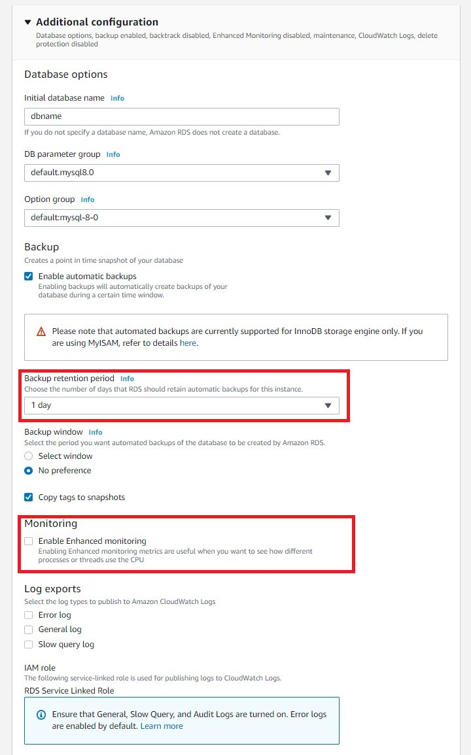

**Maintenance**

* **Auto minor version upgrade**: Select***Enable*** *auto minor version upgrade* to receive automatic updates when they become available.
* **Maintenance Window**: Select ***No preference***.

**Deletion protection**Clear *Enable deletion* protection for this tutorial. When this option is enabled, you're prevented from accidentally deleting the database.

Click **Create Database**.

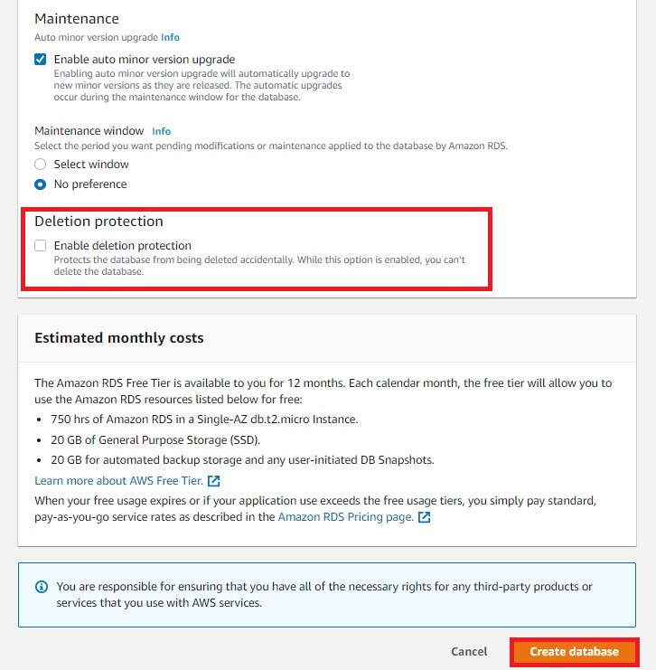

Your DB Instance is now being created.  Click **View Your DB Instances.**

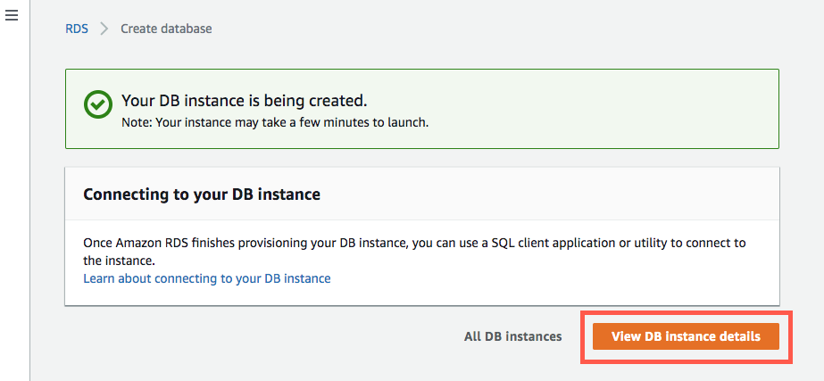

**Download a SQL Client**

Once the database instance creation is complete and the status changes to available, you can connect to a database on the DB instance using any standard SQL client.

In this step, we will download MySQL Workbench, which is a popular SQL client.

* 1. Go to the [Download MySQL Workbench](http://dev.mysql.com/downloads/workbench/) page to download and install MySQL Workbench

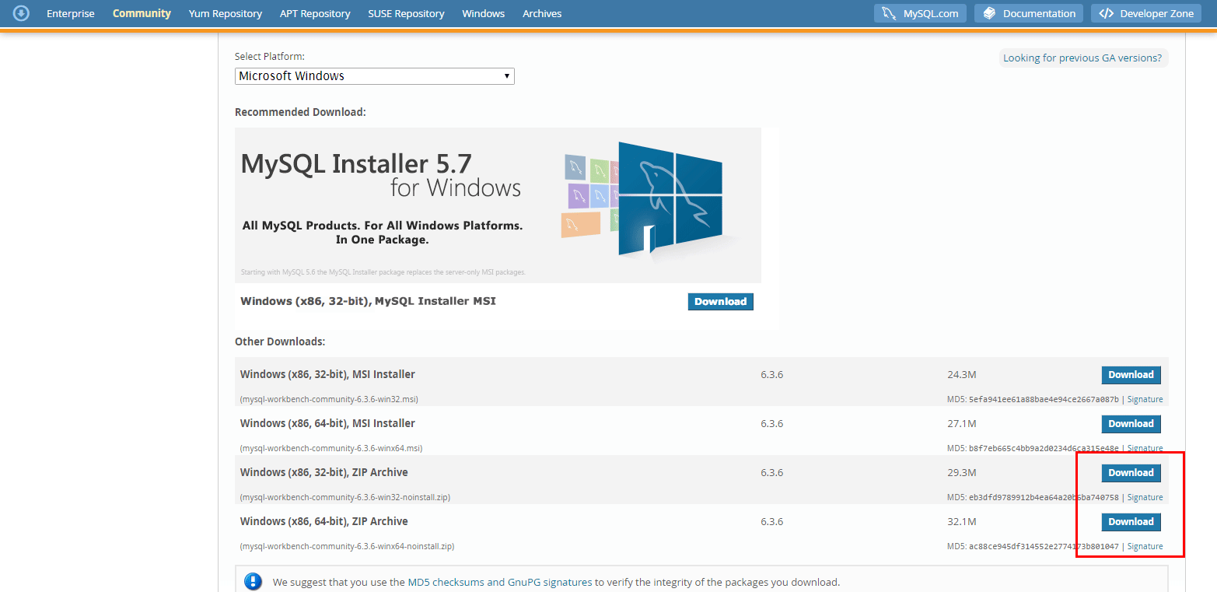

click **No thanks, just start my download** for a quick download

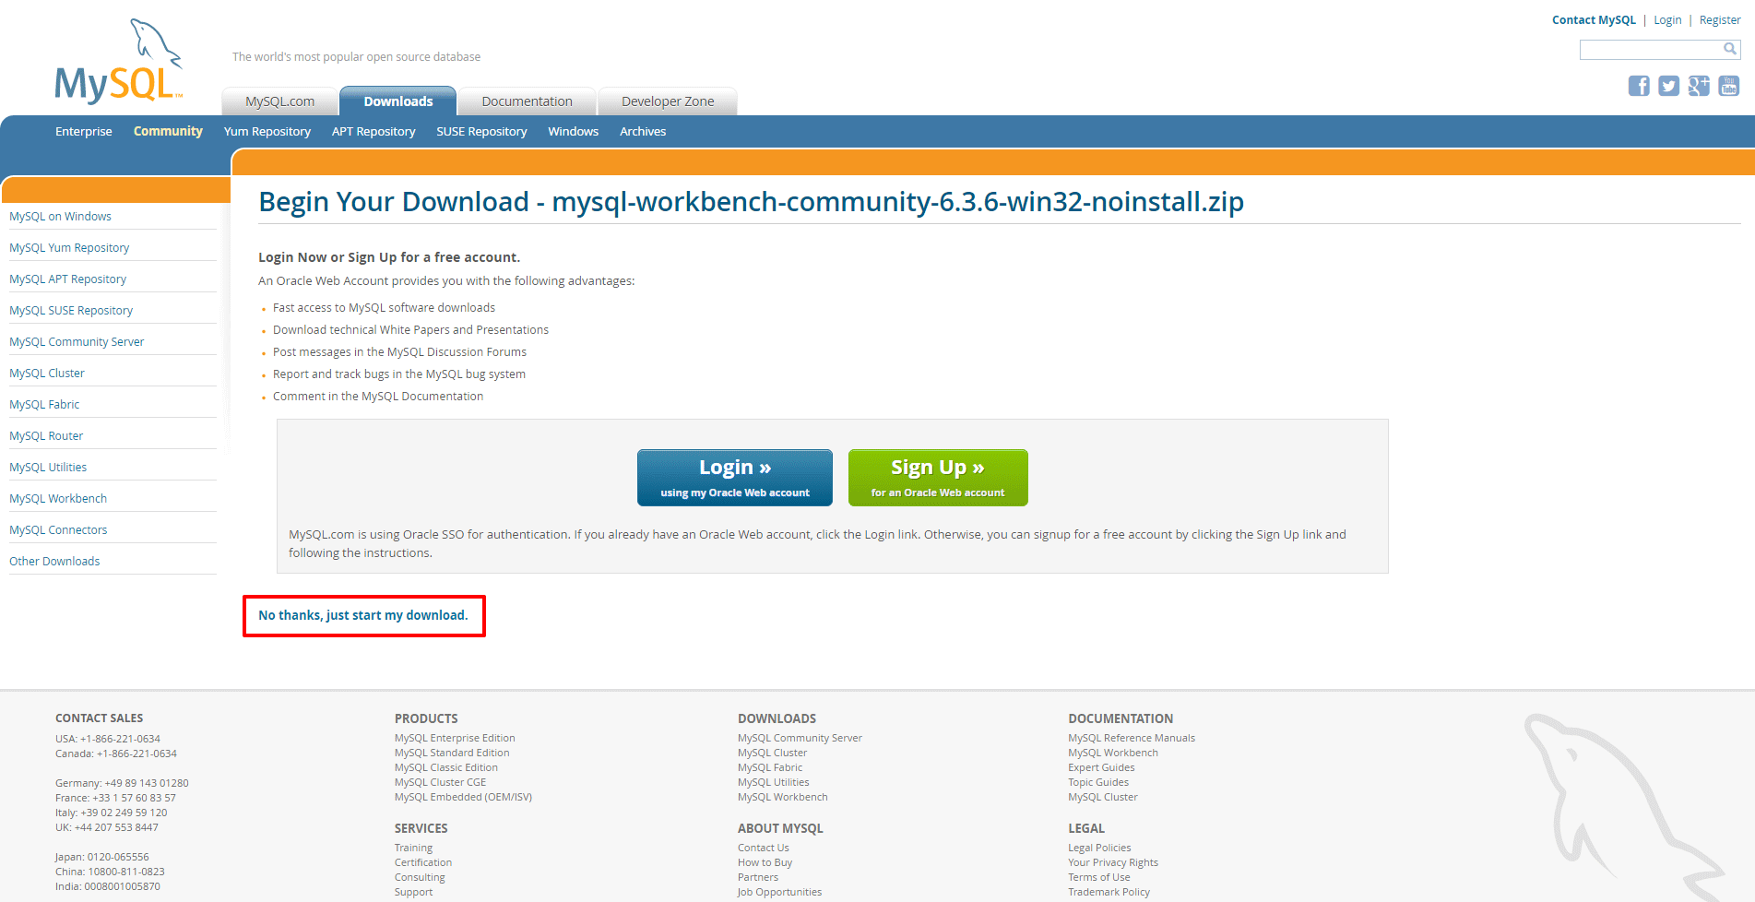

**Connect to the MySQL Database**

We will connect to the database that is created by using MySQL Workbench

Open the MySQL Workbench application and go to **Database > Connect to Database** (Ctrl+U) from the menu bar.

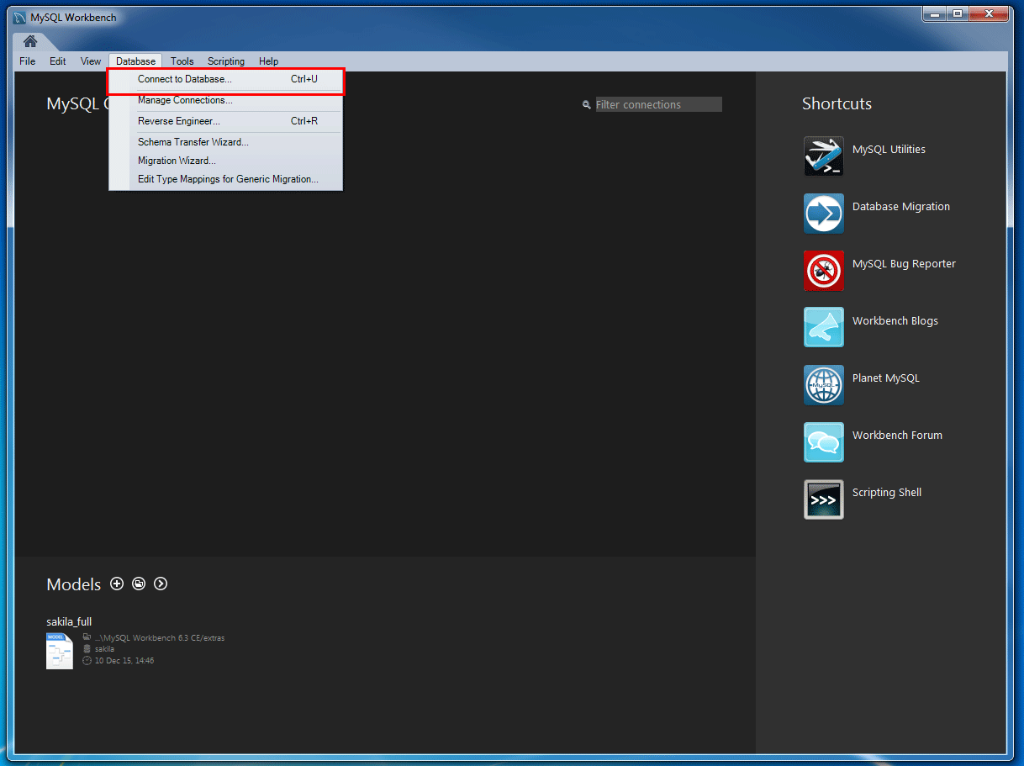

Enter the following:

* **Hostname**: You can find your hostname (**End Point**) on the Amazon RDS console as shown in the screenshot to the right.
* **Port**: The default value should be 3306.
* **Username**: Type in the username you created for the Amazon RDS database.  In this tutorial, it is '*masterUsername*.'
* **Password**: Click *Store in Vault* (or *Store in Keychain* on macOS) and enter the password that you used when creating the Amazon RDS database.

Click **OK.**

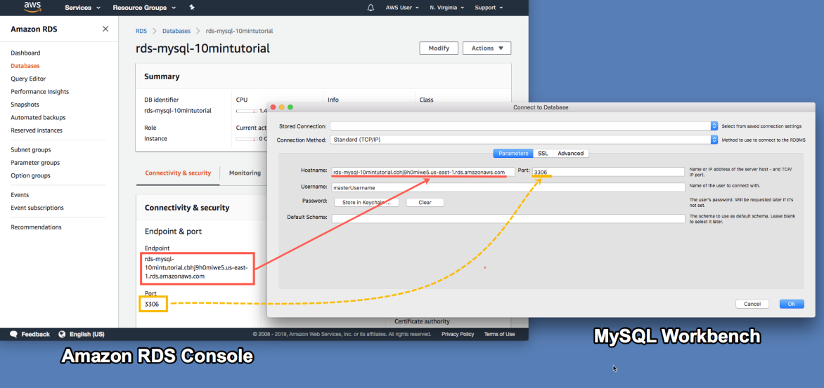

* 1. You are now connected to the database! On the MySQL Workbench, you will see various schema objects available in the database. Now you can start creating tables, insert data, and run queries.

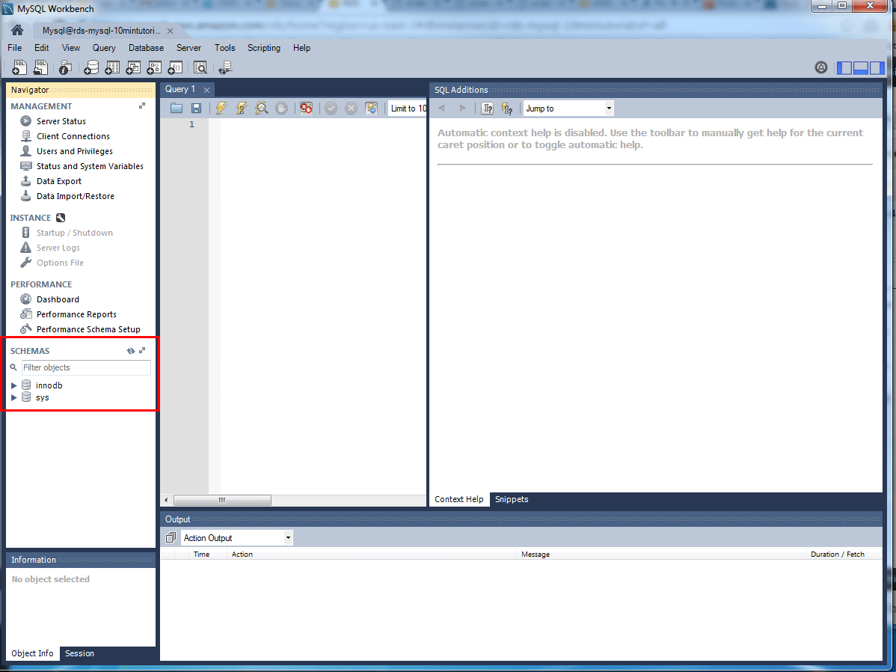

**Delete the DB Instance**

You can easily delete the MySQL DB Instance from the Amazon RDS console

* 1. Go back to your Amazon RDS Console. Select **Databases**, choose the instance that you want to delete, and then select **Delete** from the **Actions** dropdown menu.

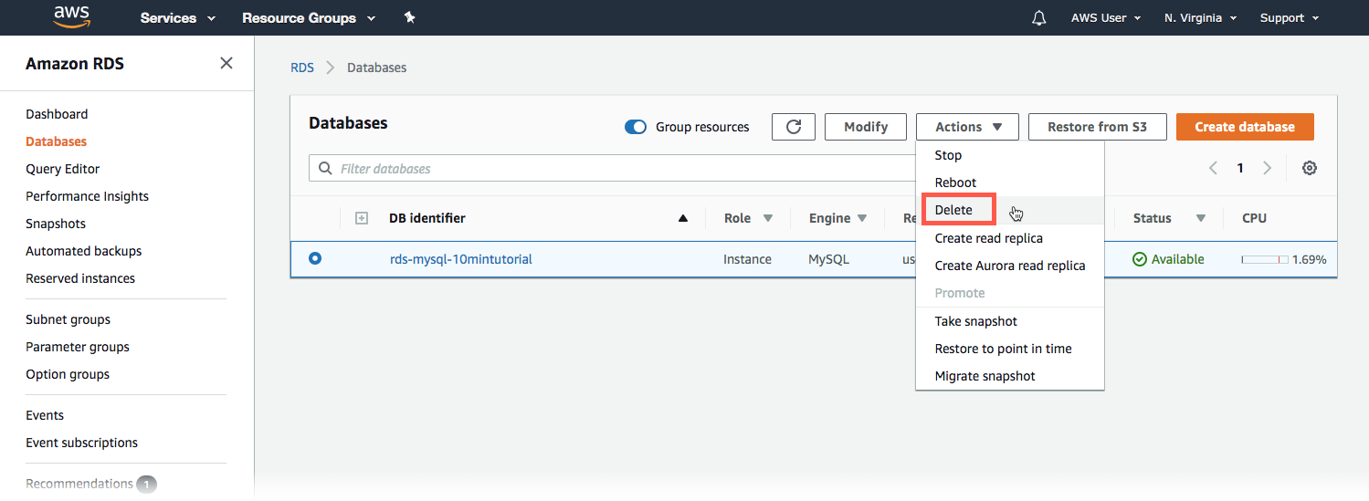

If need more help

<https://aws.amazon.com/getting-started/hands-on/create-mysql-db/>

<https://docs.bitnami.com/aws/how-to/migrate-database-rds/>

Import Application Database to Amazon RDS

<https://www.youtube.com/watch?v=7st8lYP_mJs>

<https://www.youtube.com/watch?v=bC-G4OcLr5g>